Amra digital communication dui vabay koray thaki ekta voice communication onowti data communication.

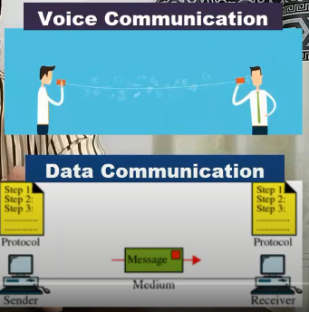

IIG hoschay international gateway orthat amra Jodi internet use koray amader desher bairay kono website visit, google browsing, youtube e kono video dektay chai tokhon amader IIG lagbai.



Like dhoray nilam ami youtube dekbo ,ekhon youtube er server assay amarica tay ekhon ekjon Bangladeshi user Jodi youtube browse kortay chai tokhon Bangladesh thekay ber hoye America tay jetay hobay, as a human amra Jodi border cross kori then boder e amader visa, passport lagay thik tamon e vabay ISP connection use koray desher bairay kono kisu access kortay chai, like youtube dektay chai tokhon ei IIG amader permission dai desher bairay jower jonnow orthat access power er jonnow. Etai IIG er kaj.



Amra Jodi Bangladesh hotay ber hoye internet er through tay call kori tokhon IGW international gate way er kaj koray thakay. Orthat voice communication er khetray IGW international transit er kaj koray je deshe e call kora hoi oi deshe e pathanor kaj koray thakay. Desher modde holay ar IGW er kono kaj nai.

Main thing ekoi IIG and IGW international gate way er kaj koray thakay. IIG data communication er jonnow ar IGW voice communication er jonnow.

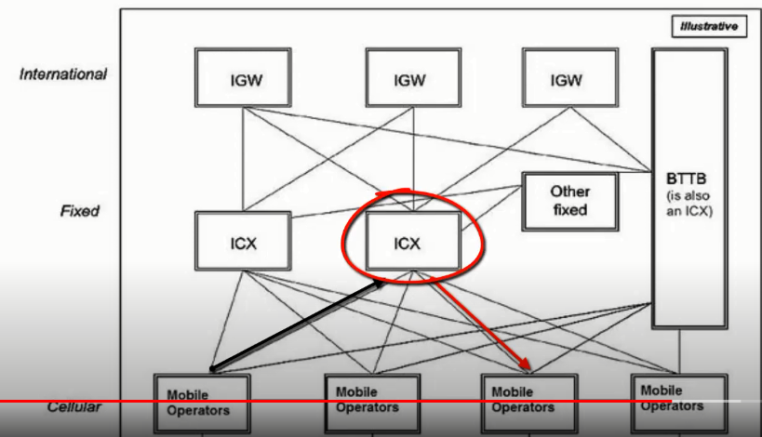

ICX and BDIX er kaj o onekta IIG o IGW er motoi. ICX and BDIX holo desher modde thakay ar IIG holo desher bairay er sathay connect koray thakay.

Ami Jodi Robi user hoi and robi user er call tai kori tokhon amer call ta robi tower e jabay enong destination e cholay jabay. Kinto ami robi user but call ta korasi grameen user kay ekhon ICX switching er moddome grammen operation er kasay cholay jabay. Orthat ICX er kasay sob operator e connected user call korar poray ICX dekhay kon operation thekay assay ark on operation e jetay hobay tokhon switching er maddome call forward koray dai.

BDIX holo amader local joto ISP assay sobgulo BDIX er maddome connect asaay ekhon ami Jodi kono wesite browsing kori jetar hosting Bangladesh er modde obostito taholay ar desher bairay jower proyojon poray na. ei advabtage ta diye thakay BDIX. Er folay number of latency komay jai, ping komay jai, local traffic hoi ar onek high speed hoi. Orthat ami Jodi emon service chai jeta asolay amader desher modde tokhon BDIX er through tay oi service er sathay connect koray dai. Jar folay eikhanay ar IIG ar IGW lagay na.

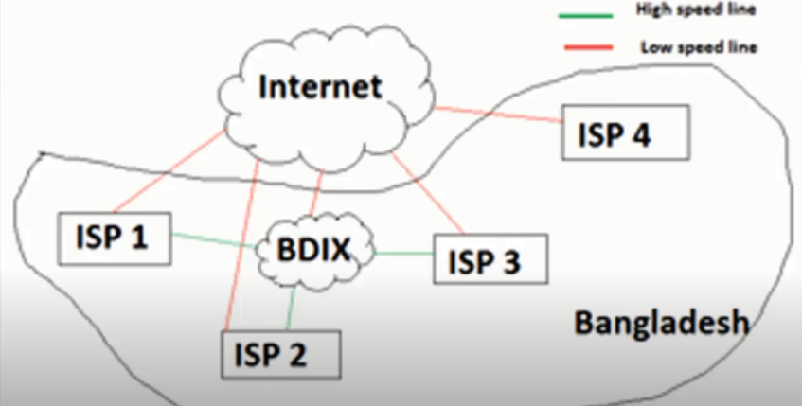

Networking command

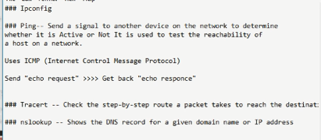

* cls – window clear.
* ipconfig --- computer er sathay ja connect assay like wifi, subnet mask ei gular address dekhabay.
* Ipconfig / all --- sobkiso detail akaray dekhabay.
* Ping -- kono website otoba kono site e amer eikhan thekay reachable kina check kora tar sathay total time check kora. Example ping google.com

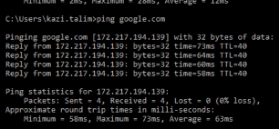

* Ping google.com –t --- ei command dilay continuous ping kortay thakbay and ctrl+c dilay themay jabay.

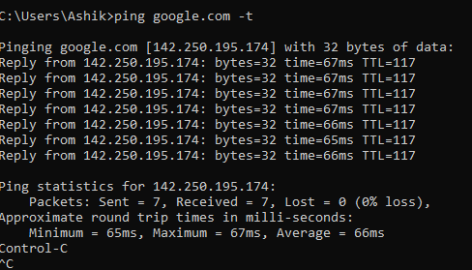

* Tracert -🡪 destination porjonto route dekhai, orthat ami Jodi tracert [www.youtube.com](http://www.youtube.com) dai then amer router thekay youtube er server porjonto jetay jotogula route use kora hoyesay sobgula dekhabay.

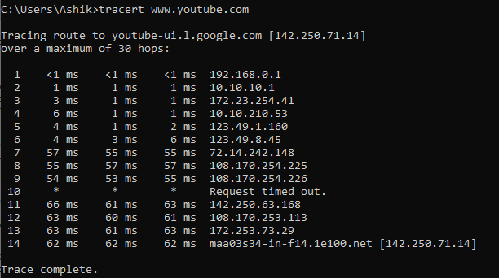

1. Amer router e rip
2. ISP provider er router er IP

GPON --- ekta port thekay 128 ta onu connect kora jai, aber 2gbps data pass hoi, ekhon Jodi ekoi elakai onek besi client hoi then gpon use kortay hobay, client Jodi ekoi elakai bartay paray, data besi ditay hoi clientder othoba in future e besi bandwidth pass kortay hobay then gpon best solution.

Epon --- ekta port thekay 64 ta onu connect kora jai, aber 1gbps data pass hoi, ekhon Jodi ekoi elakai onek besi client na hoi then epon use kortay hobay, like ekta building er 20 ta client but eikhanay ar client barbay na tokhon Epon use kora valo epnon er price kom, data kom ditay holay clientder othoba in future e kom bandwidth pass kortay hobay then epon best solution.  
  
In Present Gpon is best solution , because in future e client er number barbay ebong data pass er poriman barbai.

GPON is better than EPON

GPON supports 1:32, 1:64, 1:128. GPON provides multiple selectivities, but its cost advantage is not obvious. The maximum physical distance that a GPON system can support is 20 km when the optical splitting ratio is 1:16. When the optical splitting ratio is 1: 32, the maximum physical distance should be 10 km.

**EPON:**EPON standard splitter ratio is 1:16~1:32. In fact, the EPON system can also achieve higher splitter ratio, such as 1: 64,1: 128, [EPON OLT](https://www.optcore.net/product/epon-olt-sfp-transceiver/) can support more [EPON ONU](https://www.optcore.net/product/epon-onu-sff-2x5-1000base-px20-transceiver/). The splitter ratio is mainly limited by the performance of the optical module.

**GPON:** [GPON](https://www.optcore.net/gpon-vs-epon-difference/) supports a variety of data rate levels, which can support asymmetric uplink and downlink rates, downlink 2.5Gbps or 1.25Gbps, uplink 1.25Gbps or 622Mbps. Users can determine uplink and downlink rates according to actual needs and select the corresponding optical transceiver to improve the optical device value for money.

**EPON:** [EPON](https://www.optcore.net/overview-of-gepon-technology/) provides fixed uplink and downlink data rate of 1.25Gbps, using 8b / 10b line coding, and the actual rate of 1Gbps.

Ethernet protocol has no inherent QoS capability. Because a PON system is not viable without QoS, most vendors enable this in EPON by using VLAN (Virtual Local Area Network) tags. While this does solve the QoS problem, it puts much higher costs. Since there is no automatic provisioning of VLAN tags, they are often provisioned manually. GPON has integrated QoS handling that makes it better than EPON, because EPON QoS is high cost relative to GPON. (Figure.3)

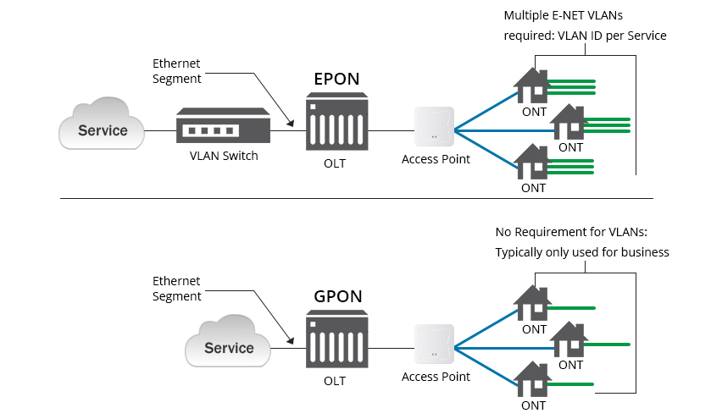

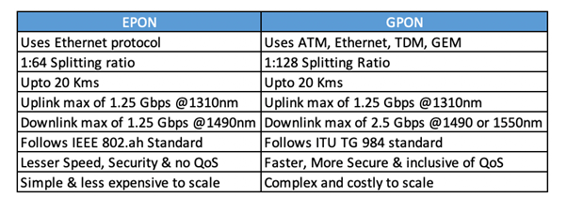

Onu(optical network unit) – media converter  
Onu and Mc are similar type, kajer method o ekoi

MC- electronic signal kay alok signal e convert koray aber alok signal kay electronic signal e convert kortay pary, orthat er kajta vice versa ar ki

ONU – Onu only alok signal kay electronic signal e convert koray.

ISP company Jodi olt thekay ftth(fiber to home) connection hoi then basa baritay ekta onu lagay.

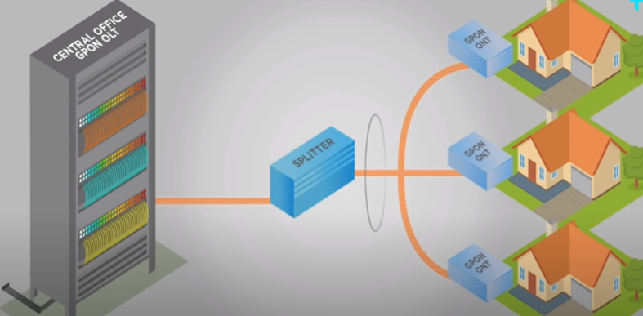

Orthat ONU alok signal kay electronic signal e convert koray router othoba direct PC tay connect korbay.

Serverta Jodi olt mood e na thakay then mc use kortay hoi, old module e server thaklay MC use kortay hoi.

Onu 3 kinds--- epon, gpon, xpon

Server Jodi Epon hoi then basai epon onu connect kortay hobay. Server Jodi gpon hoi then basi gpon onu connect kortay hobay. Ar Jodi server ki epon naki gpon jani na then xpon use korbo, orthat xpon onu epon and gpon dui olt tai kaj koray xpon onu.